Ailshie, Taylor – Head Coach
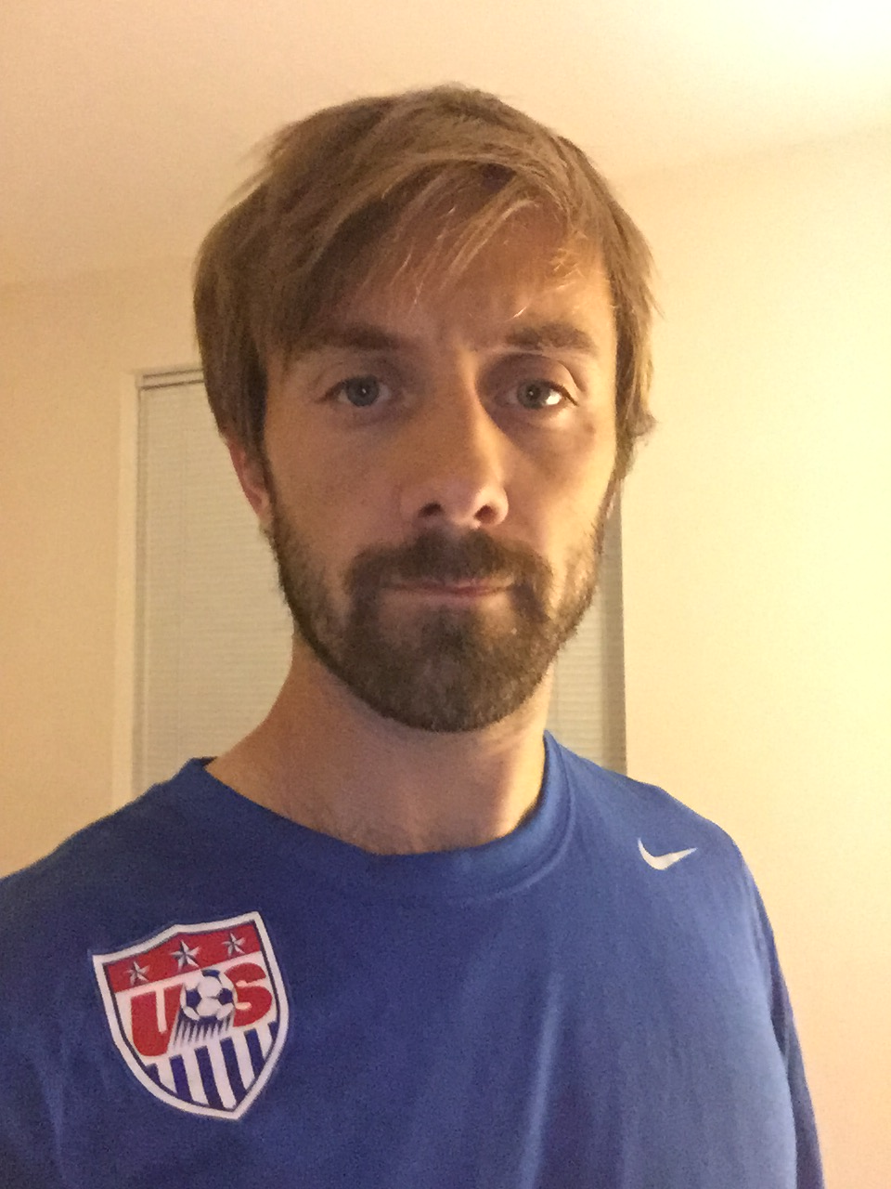  410.693.9590  TaylorAilshie@yahoo.com  2017-2018 Teams  ASA Rangers White 04’ – EDP Division 2  We are looking for a few talented, soccer-focused players that can play EDP Div 2 in the fall and in the spring with a futsal session in the winter. Players are expected to attend practices (2-3 a week) on a timely manner prepared to learn advanced soccer techniques and tactics for the 11v11 game. Players will develop highly competitive fitness levels and learn to take care of their mind and body in preparation for future careers in the sport. Character development is the cornerstone of the Rangers teams where leadership, sportsmanship, and accountability are center focus to build a lifetime of success and confidence on and off the field. | Education:  - USSF National ’C’ License (2015)  - USSF National ’D’ License (2014)  - USSF National ’E’ License (2013)  - First Aid Certified
Coaching Experience:
- MD State ODP Coach (2017)
- ASA Rangers Blue 04’ – EDP Div 3 -Promoted to D2 (Fall 2016)
- ASA Rangers Blue 03’ – NCSL Division 5 Champions (Fall 2015)
- ASA Rangers White 03’ – CMSSL Division 1 Champions (Fall 2015)
Playing Experience:
High School Level
- South River (County Champions 2001-02)
Amateur Level
- WPL (DC)
- Multiple County Championships
- 2011 Maryland Major Soccer League Champion
- Pipeline Soccer Club (2012 State Cup Finalist)

